DOI: 10.xxxxx/xxxxx.xxx.xx
Received: xxxxxxxxxxxx
Published: xxxxxxxxxxxx
PACS/topics: keywords, for, your, article
Full title of article
usually taking two lines
F. Author¹*, S. Author²
¹First affiliation
²Second affiliation
*e-mail: corresponding author e-mail address

Really short summary of the article.
Preferably two to four sentences long.

Paragraph title
Paragraph text. A blank text and nothing more. Lorem ipsum dolor sit amet, consectetur adipiscing elit, sed do eiusmod tempor incididunt ut labore et dolore magna aliqua. Ut enim ad minim veniam, quis nostrud exercitation ullamco laboris nisi ut aliquip ex ea commodo consequat. Duis aute irure dolor in reprehenderit in voluptate velit esse cillum dolore eu fugiat nulla pariatur. Excepteur sint occaecat cupidatat non proident, sunt in culpa qui officia deserunt mollit anim id est laborum.
Second paragraph title
Blak table | To present your data
Cell 1 | Cell 2
Cell  3 | Cell  4
Table 1. Table 1 description.
Second paragraph blank text. Lorem ipsum dolor sit amet, consectetur adipiscing elit, sed do eiusmod tempor incididunt ut labore et dolore magna aliqua. Ut enim ad minim veniam, quis nostrud exercitation ullamco laboris nisi ut aliquip ex ea commodo consequat. Duis aute irure dolor in reprehenderit in voluptate velit esse cillum dolore eu fugiat nulla pariatur. Excepteur sint occaecat cupidatat non proident, sunt in culpa qui officia deserunt mollit anim id est laborum.

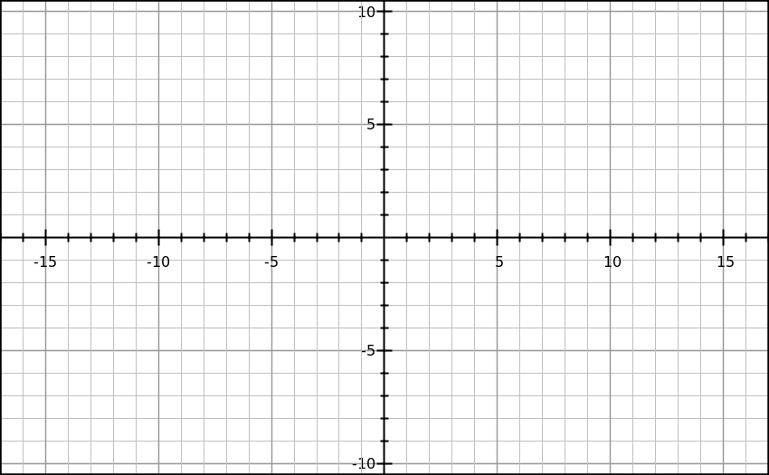
Fig. 1 Figure 1 description.
In this¹ part of text we present² the use of references³. References style is Nature⁴.
Acknowledgements: Authors would like to thank
A. Bianco, E. Busetto and I. Cudin from Synchrotron Elettra, Trieste for beamline optical design optimization and support during the design period.
References
1. Hisakata, R., Nishida, S. & Johnston, A. An adaptable metric shapes perceptual space. Curr. Biol. 26, 1911–1915 (2016).
2. Musk, E. The secret Tesla Motors master plan (just between you and me). Tesla Blog https://www.tesla.com/blog/secret-tesla-motors-master-plan-just-between-you-and-me (2006).
3. Hogue, C. W. V. Structure databases. in Bioinformatics (eds. Baxevanis, A. D. & Ouellette, B. F. F.) 83–109 (Wiley-Interscience, 2001).
4. Sambrook, J. & Russell, D. W. Molecular cloning: a laboratory manual. (CSHL Press, 2001).

